**Cycle Master Issues & Possible Improvements**

1. The GUI interface is “wonky” to use a technical term when loading the power curve file. If you drag it around the screen or attempt to click around in Windows, it breaks apart, allowing parts of the background to be visible (see picture). It also lags when you try to drag it around, resulting in a residual images (i.e., the gui graphics aren’t being quickly erases and redrawn in their new position on the screen).

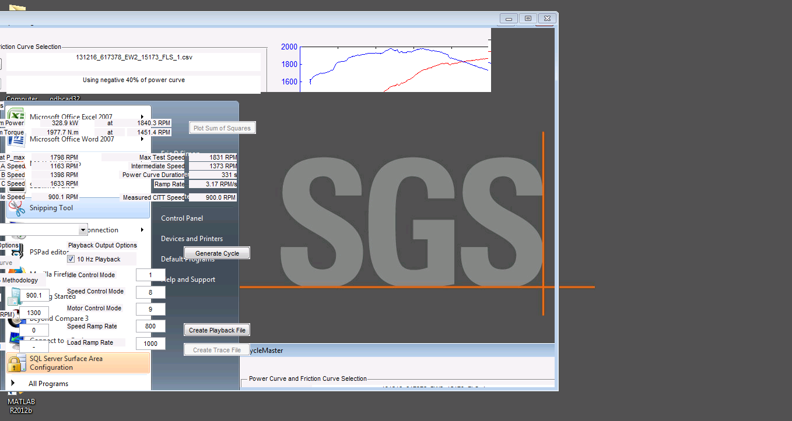

1. The power curve file takes FOREVER to load (if forever is defined as approximately a minute). The attached image represents the portion of a profile report that shows the time spent on various tasks. Notice that the real culprit is the mimport.m file, and more specifically the massive number of str2double calls.

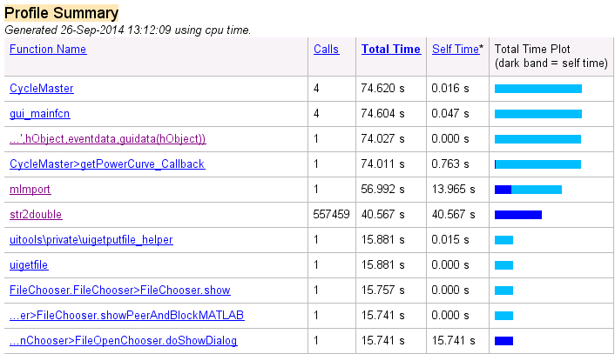

1. The interface could be improved by adding tool tips to explain the quantities being displayed and/or describe functionality.
2. Various text labels (e.g., Max Test Speed, Intermediate Speed, Maximum Power, etc.) could be made clickable such that these quantities or “limits” were added to the power curve. For example, clicking on Maximum Power could identify the point of Maximum Power on the graph, making it clear at a glance. The Ramp Rate could reveal two vertical lines when clicked, indicating the area over which the duration was calculatedthe power curve. Clicking the A Speed label could show a horizontal line indicating the location on the graph of A Speed value provided.
3. Cycle Master still relies on modes to calculate various quantities. We could include a “Ignore Modes” option and calculate these various regions from the data.
4. The requirements mapping I began to relate requirements to software functionality is obviously still incomplete. As I noted earlier, this provides a way of validating the software and making certain it is performing as required.
5. There are still a lot of hard coded directories in the code. I tend not to like that sort of thing as it makes the software less portable and harder to test. For now, I left most of it.